EuroLiner™

Installation Guidelines

- Affix the EuroLiner to its final installation location by means of the holes supplied in the unit’s flanges with anchor bolts or studs and nuts.
- Install EuroLiner’s electrical connections on the Load Side of the lighting breaker.
- Make sure the load you are going to treat with EuroLiner is switched off by its service disconnect. Install the wires feeding the EuroLiner following N.E.C. guidelines and/or local codes.
- For 120/277/347V single-breaker units, connect the wires as shown in Figure 1 where:

Terminal 1: Connected to the circuit breaker
Terminal 2: Connected to the White Neutral Bar
Terminal 3: Connected to the Black Wire of the Lighting Load

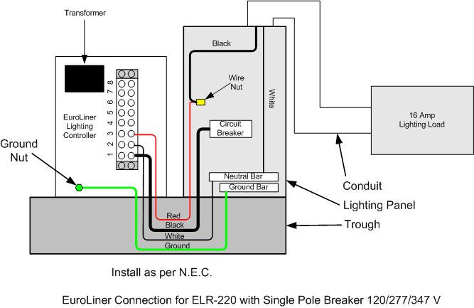
Figure 1 – Typical Wiring Diagram

- For 208V double-pole units, connect the wires as shown in Figure 2 where:

Terminal 1: Connected to Circuit Breaker #1
Terminal 2: Connected to Circuit Breaker #2
Terminal 3: Connected to the Black Wire to the Lighting Load
Terminal 4: Connected to the Neutral Bar in the breaker panel

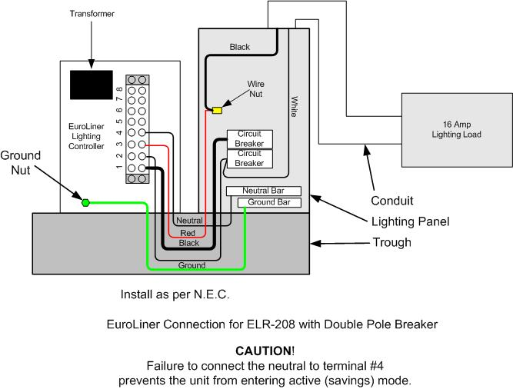
Warning: the White (Neutral) wire from the load must be
repositioned from the neutral bar to Circuit Breaker #2.

Figure 2 – 208V Double-Pole Wiring Diagram

- For 220-240V double-pole units, connect the wires as shown in Figure 3 where:

Terminal 1: Connected to Circuit Breaker #1
Terminal 2: Connected to Circuit Breaker #2
Terminal 3: Connected to the Black Wire to the Lighting Load

Warning: the White (Neutral) wire from the load must be
repositioned from the neutral bar to Circuit Breaker #2.

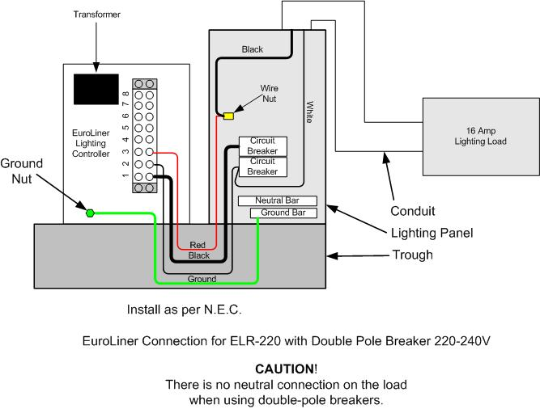
Figure 3 – ELR-220 Double-Pole Wiring Diagram

- Make a final visual inspection and make sure all the connections are firmly tightened and the ground lug is connected to earth ground or the facility’s ground system. Also, clean the interior of EuroLiner enclosure and make sure no scrap wire or metal debris is loose inside.
- Apply power to the Treated Load. Load should work as usual. After 10 minutes, the unit should enter active (savings) mode.
NOTE: If this is a 208V unit and the system does not enter savings mode, check that terminal #4 is connected to the neutral bus as shown in Figure 2.

