IllumiLiner™ 20

Universal Lighting Controller (ULC)

Installation:

- Select the proper DIP switch setting for SW2 for the type of lights you plan to control. Change the settings by depressing the appropriate DIP switch with a ball point pen. (See below.)

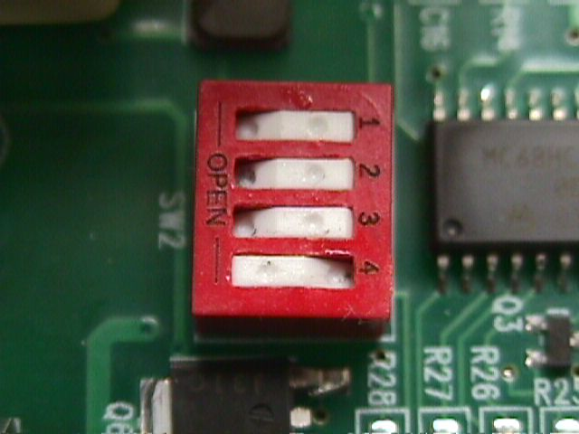 | 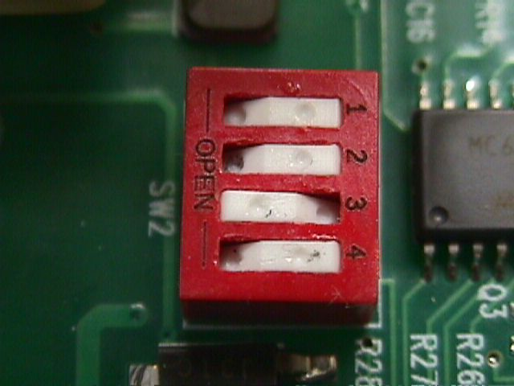 | 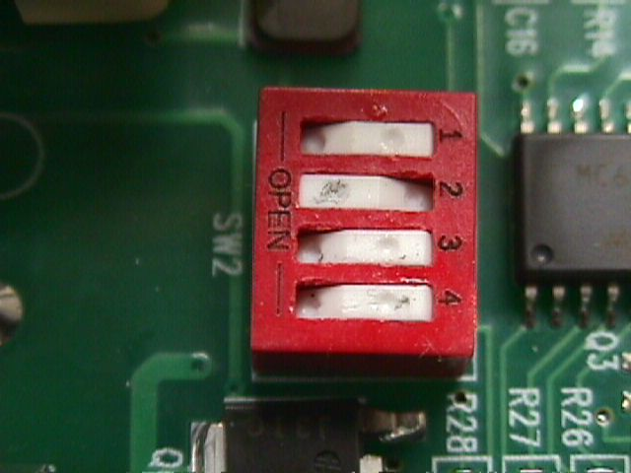
Fluorescent Mode | HID Mode | Specialty Mode

- Connect white wire to incoming neutral.
- Connect black wire to incoming hot. (20A breaker maximum.)
- Connect red wire to load. (Load is connected between the red wire and neutral).
.

- Set the large Bypass switch to SAVINGS MODE
- When used, digital input one is connected between TB1-1 and TB1-2.
- When used, digital input two is connected between TB1-3 and TB1-4. (See Figure 1.)
- Pot positions for R1 / R12:
Full CCW = Minimum Savings
Full CW = Maximum Savings

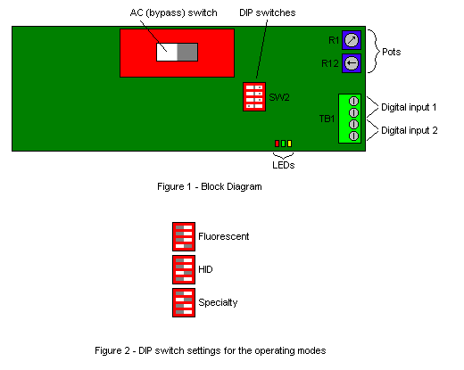

Operation:

The IllumiLiner can be configured to operate in one of three modes: fluorescent, high intensity discharge (HID), and specialty. These modes are selected by the positions of the DIP switches. A switch is considered “on” when in the closed position. See Figure 2 for the various settings used to configure the different modes. Set the large bypass switch to SAVINGS mode. Once this is done, the unit may be powered up.

Upon power up, the LEDs will flash to indicate the mode selected. Either:

- The green LED will flash several times to indicate fluorescent mode.
- The red LED will flash to indicate HID mode.
- The yellow LED will flash to indicate specialty mode.
- All three LEDs will flash. This indicates that the DIP switches are set to an invalid mode. If this occurs, turn power to the IllumiLiner off, reconfigure SW2 and turn power back on.

After the unit has finished displaying the LED code, it will precede to operate in the selected mode. The large bypass switch can always be used to bypass whatever the unit is doing, and apply full power to the load.

Explanation of Fluorescent operating mode:

In the fluorescent mode, the IllumiLiner provides full power to the load for eight minutes, and then enters the savings mode, in which only a portion of the AC signal is applied to the load. If neither digital input is active, then the amount of savings is determined from the position of the pot R1 (turning the pot clockwise increases the amount of savings).

If an input is applied to digital input 1, then the savings is determined from the position of the pot R12. If an input is applied to digital input 2, then the unit is placed in bypass mode, and full power is applied to the load.

Explanation of HID operating mode:

In the HID mode, the IllumiLiner provides full power to the load for eight minutes, and then gradually ramps the power from full-on to the final savings level over a period of three minutes. While the unit is ramping, the amber LED comes on.

Explanation of Specialty operating mode:

The specialty mode operates much differently from the other two modes. In the specialty mode, the power is applied to the load for initially for ten seconds. The IllumiLiner then goes into a “flashing” mode, where the power to the load is turned on and off repeatedly for a period of twelve seconds. The rate of flashing is set through the position of pot R1 (turning the pot clockwise decreases the flashing frequency). The rate of flashing varies from 10-30 hertz for 60 cycle AC, and from 8.333-25 hertz for 50 cycle AC.

While the IllumiLiner is in the “full-on” mode, the red LED comes on, and when the unit is in the “flashing” mode, the green LED comes on.

When no digital inputs are applied, the IllumiLiner goes into bypass mode, and the output is supplied constant full power. When either digital input is active, the IllumiLiner operates in the flashing mode.

Digital inputs:

The two digital inputs on TB1 take either a 24V DC input, or a 24V AC input. They are defined as “on” or “active” when the voltage is applied, and as “off” or “inactive” when there is no voltage between the terminals. Digital input one is across pins 1 and 2 of TB1, and digital input two is across pins 3 and 4 of TB1. The polarity is not important.

